Hi, We did make this project so it can be useful to understand the REF template.

So this is a selfmade REF-template (much easier to understand). After this excercise you will get the main processes of the REF processes.

First we will look at our flow-chart (you need to know your flowchart before you start making processes).

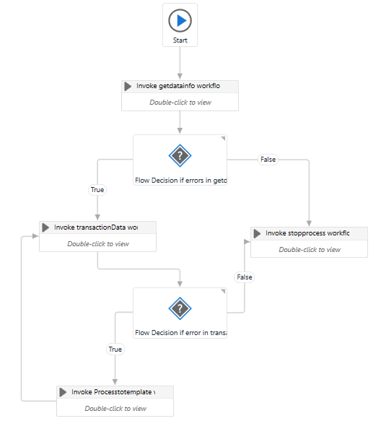

Always start with the getdatainfo workflow (init). We use this process because we need to be sure we get all the data in 1 process and it is done before we start other processes. This forms the baseline for our process (i.e. “what apps/programs need to be open and what data do we need in order to complete the process”)

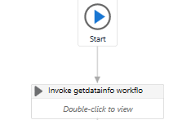

After opening this process, we use 2 try catch functions so we can debug and log all the processes.

I assign a CountError because I set this on “1” in the catch when there is an error, so it can stop the process directly.

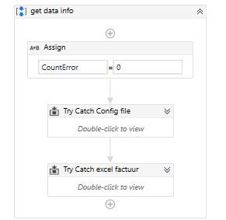

We will look at 1 try catch:

We create a datatable in uipath so we can use that without having to alter the excel file we start with.

Also in the catch I will set an system exception, so we can get the exception.

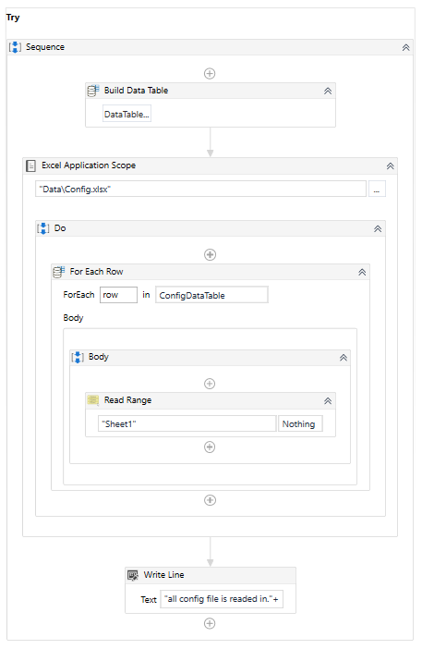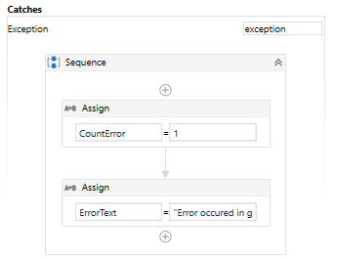

We make a flow decision so it checks if there is an errorCount. If there is then it will go to stop process (red arrow). If there is no error it will continue to transaction data (green arrow).

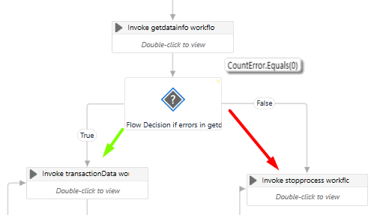

We use the get transaction data to assign each info to a variable. These variabels will go to an argument so we can use the arguments in different processes.

You can see in the screenshot bellow that we assign each row item from excel into an argument.

After putting the first row in to variabels, we will delete this row from the datatable we did make in the beginning. If we don’t do this, then it will always take the same row. So if we delete the first “remove row”(0)🡪 the second one will take the place. The process will keep doing this until there are no more rows left (i.e. no more data available to use in the process) Just check my Picasso here:

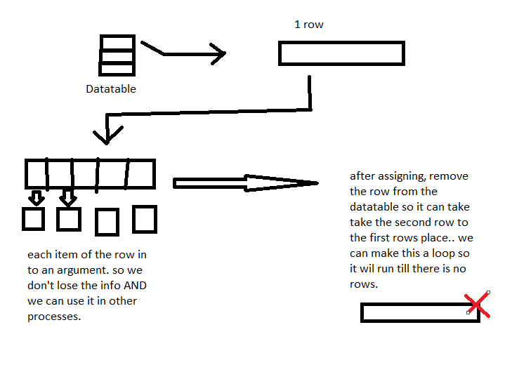

In UIpath it will look like this: 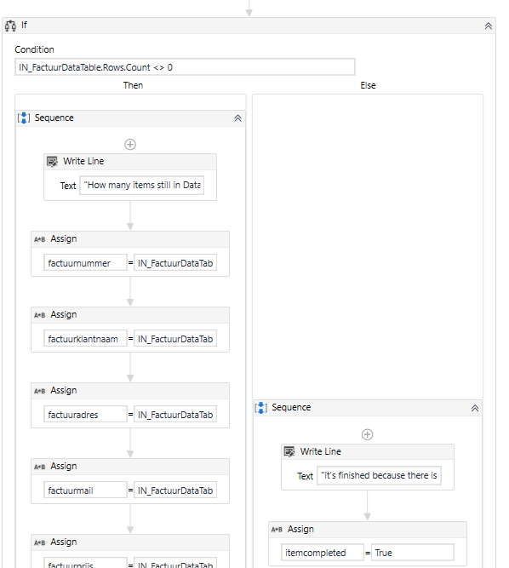

Let’s go to the last process (you can use this to make actions with the data you did get and transact from the previous processes).

This process will use the data that we got from the previous process (transactdata).  
After it has completed the actions in the process invoke transaction data, it will loopback to transact the next data so it can get the next row information through arguments. (example: typing this info into a .pdf)

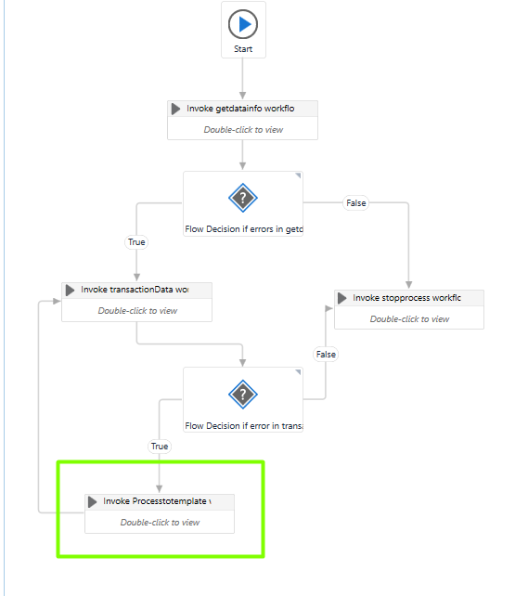

If there is no transaction data anymore the process will stop, and if you open the stop process workflow you can see that I use an “if” statement so I can see why the process is finished (through an error or just finished because the process is done.)

